|  |  |
| --- | --- |
| **Networking Infrastructure**  Diploma in CSF / IT  Apr 2020 Semester (Semester 3) | Week 7 |
| **Practical** |
| Configure VLANs in Layer 3 Switch | |

**Objectives**

At the end of this practical, student should be able to:

1. understand the basic concept of two VLANs in a switch;
2. understand how VLAN works
3. **Introduction**

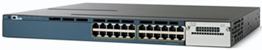

The Cisco **WS-C3560X-24T-S** Ethernet switch as shown above is a layer 3 switch. It has 24 switch ports providing the normal switching function. It can support Virtual LANs (VLAN). However, it also has basic routing functions, including static routing and the Routing Information Protocol (RIP). The switch ports can be configured to be router ports/interfaces to allow different subnets or networks to be connected to the switch.

**Note:**

Before configuring the Cisco 3560 switch, execute the command below to make sure that there are no VLAN configured on the switch.

#show vlan brief

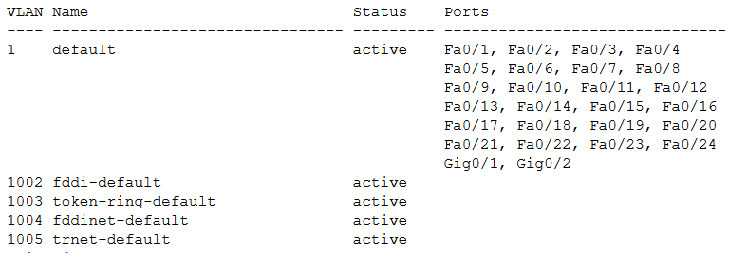

It means that the switch has no VLAN configured

(Proceed to 2. Configure the Catalyst 3560 to support VLANs)

1. **Configure the Catalyst 3560 to support VLANs**
   1. **Using default VLAN**

By default, the switch ports in the Catalyst 3560 are all in VLAN 1. Setup PC 1 and PC 3 as shown in Figure 2.

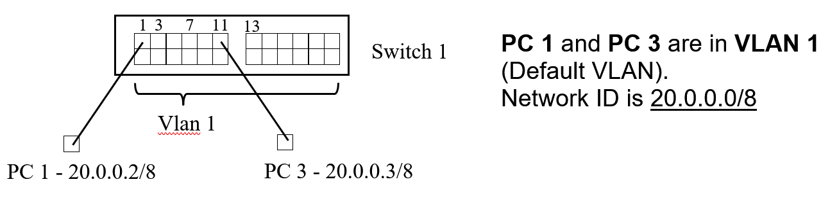

Figure 2

Before creating the VLANs, configure the following IP addresses for PCs:

|  |  |  |  |  |
| --- | --- | --- | --- | --- |
| **PC** | **Switch 1** | **VLAN (default)** | **IP Address** | **Subnet Mask** |
| PC 1 | 1 | VLAN 1 | 20.0.0.2 | 255.0.0.0 |
| PC 3 | 1 | VLAN 1 | 20.0.0.3 | 255.0.0.0 |

Show that PC 1 and PC 3 can ping each other as they are in the same physical switch, with the same IP network.

* 1. **Create VLANs**

By default, the switch ports in the Catalyst 3560 are all in VLAN 1. Create two VLANs namely vlan 2 and vlan 3 for the Sales and Admin department users respectively.

(config)#vlan 2 ; create a VLAN with vlan Id 2

(config-vlan)#name Sales ; name vlan 2 as Sales

(config-vlan)#end ; return to Privileged mode #

#show vlan brief ; show status of VLAN

(config)#vlan 3 ; create a VLAN with vlan Id 3

(config-vlan)#name Admin ; name vlan 3 as Admin

(config-vlan)#end ; return to Privileged mode #

#show vlan brief ; show status of VLAN

* 1. **Assign VLAN memberships to the switch ports**

1. vlan 2 has these member switch ports: Fa0/1 to Fa0/6

# config t

(config)#interface range Fa0/1-6 ; specify ports 1 to 6

(config-if-range)#switchport access vlan 2 ; place these ports into Vlan 2

(config-if-range)#no shut

(config-if-range)#end

#show vlan brief

1. vlan 3 has these member switch ports: Fa0/7 to Fa0/12

#config t

(config)#interface range Fa0/7-12 ; specify ports 7 to 12

(config-if-range)#switchport access vlan 3 ; place these ports into Vlan 3

(config-if-range)#no shut

(config-if-range)#end

#show vlan brief

* 1. **Testing Connectivity**

1. Test whether PC 1 and PC 3 can ping each other after you have configured both VLANs.

|  |  |  |  |  |
| --- | --- | --- | --- | --- |
| **PC** | **VLAN** | **IP Address** | **To PC 1:** | **To PC 3:** |
| PC 1 | vlan 2 | 20.0.0.2 |  | Failed |
| PC 3 | vlan 3 | 20.0.0.3 | Failed |  |

Explain the results.

PC 1 and PC 3 is in different VLAN

1. Disconnect PC3 from port 11 and connect to port 6. Test whether PC 1 and PC 3 can ping each other.

|  |  |  |  |  |
| --- | --- | --- | --- | --- |
| **PC** | **VLAN** | **IP Address** | **To PC 1:** | **To PC 3:** |
| PC 1 | vlan 2 | 20.0.0.2 |  | Pass |
| PC 3 | vlan2 | 20.0.0.3 | Pass |  |

Explain the results.

After PC 3 moving to port 6, PC 3 is move to VLAN 2, therefore they to communicate with each other